Coding Challenge.

The following is going to describe the minimum requirements for our coding challenge. We will need to have the code uploaded to GitHub and provided the link (viewable and downloadable) once you finished. If we are unable to download or access the given link, we will automatically discard the challenge, so please be aware of any security settings and allow public view of the bucket.

For the contents expected in the Github bucket are:

* Visual Studio Solution.
* Database Creation Scripts and Data Loading Scripts.

**Database:**

We require from you to create a database (preferable on SQL Server, but any type will do) and create the following tables:

User

|  |  |
| --- | --- |
| COLUMN | TYPE |
| Id | INT PK NOT NULL |
| FirstName | VARCHAR(50) NOT NULL |
| LastName | VARCHAR(50) NUL NULL |

Project

|  |  |
| --- | --- |
| COLUMN | TYPE |
| Id | INT PK NOT NULL |
| StartDate | DATETIME NOT NULL |
| EndDate | DATETIME NOT NULL |
| Credits | INT NOT NULL |

UserProject

|  |  |
| --- | --- |
| COLUMN | TYPE |
| UserId | INT FK NOT NULL |
| ProjectId | INT FK NOT NULL |
| IsActive | BIT NOT NULL |
| AssignedDate | DATETIME NOT NULL |

**NOTE:** You will be in charge of adding 3 users and 5 Projects to each user and assign those through UserProject. Make sure that you add Assigned dates that are less and greater than the Projects Start date, to prove the next step.

**Application:**

We need an MVC application that connects to the previously created database through EntityFramework (DB First), using the best principles and coding practices.

You will have a Single Page (index), and through javascript libraries (JQuery) you will call the MVC controllers to obtain the needed information to construct the next mockup:

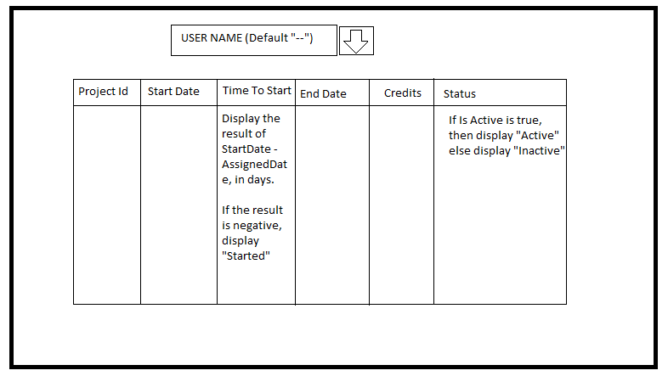

This single page application will have a dropdown with a User list (by default none is selected, so display “--”). When a user is selected, the table presented must be filled with the data from the corresponding tables. Please take note that you have 2 calculated columns.

Construct the application using as many layers as needed, to be able to get the data needed to present it in the closest way to the mockup.